Programming with Python & Problem Solving (05MC0107)

Lab Manual (2026-27)

Program: MCA Semester: 1
Name of the Student: Chandan Kumar Enrolment No.: 92600584106

INDEX

Lab | Program | Date | Remarks | Signature
1 | Write a program to demonstrate basic input and output operations in Python. | 17/08/2026
2 | Write a program to illustrate the use of different data types and type casting. | 17/08/2026
3 | Write a program to perform arithmetic relational and logical operations using Python  operators. | 17/08/2026
4 | Write a program to demonstrate string operations including slicing formatting and built-in string functions. | 17/08/2026
5 | Write a program to create and manipulate lists using indexing slicing and list comprehensions. | 17/08/2026
6 | Write a program to illustrate the use of tuples and sets with basic operations. | 17/08/2026
7 | Write a program to create a dictionary and demonstrate dictionary methods and iteration. | 17/08/2026
8 | Write a program to explain mutable and immutable objects in Python. | 17/08/2026
9 | Write a program to define and use user-defined functions with different types of arguments. | 17/08/2026
10 | Write a program to demonstrate recursion using factorial or Fibonacci series. | 17/08/2026
11 | Write a program to demonstrate conditional statements using if if-else and if-elif-else. | 30/08/2026
12 | Write a program to check whether a number is positive negative or zero using nested  conditions. | 30/08/2026
13 | Write a program to generate a multiplication table using a for loop. | 30/08/2026
14 | Write a program to find the sum of digits of a number using a while loop. | 30/08/2026
15 | Write a program to demonstrate the use of break continue and pass statements. | 30/08/2026
16 | Write a program to iterate over lists strings and dictionaries using loops. | 30/08/2026
17 | Write a program to demonstrate list dictionary  and set comprehensions. | 30/08/2026
18 | Write a program to illustrate variable scope using local global and nonlocal variables. | 30/08/2026
19 | Write a program to demonstrate iterators and iterables in Python. | 30/08/2026
20 | Write a program to generate a sequence of numbers using generator functions and yield keyword. | 30/08/2026

21 | Write a program to create and import a userdefined module. | 10/10/2026
22 | Write a program to demonstrate different import mechanisms in Python. | 10/10/2026
23 | Write a program to perform mathematical operations using  math module. | 10/10/2026
24 | Write a program to generate random numbers using random module. | 10/10/2026
25 | Write a program to display current date and time using  datetime module. | 10/10/2026
26 | Write a program to perform file and directory operations using os and sys modules. | 10/10/2026
27 | Write a program to copy move and delete files using shutil module. | 10/10/2026
28 | Write a program to demonstrate basic regular expression pattern matching. | 10/10/2026
29 | Write a program to use re module functions such  as match search and findall. | 10/10/2026
30 | Write a program to extract specific information from a text file using regular expressions. | 10/10/2026
31
32
33
34
35
36

Definition:
Write a program to create and import a userdefined module

Aim/Objectives:
- To understand the concept of Python modules.
- To create a module with user-defined functions.
- To save the module in a separate Python file.
- To import the module into another program.
- To call functions from the imported module.

Source Code:
module.py def add(a, b):
return a + b
def multiply(a, b): return a * b
main.py
import mymodule
print("Addition:", mymodule.add(10, 5))
print("Multiplication:", mymodule.multiply(10, 5))
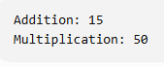

Conclusion:
Thus, a user-defined module was created and successfully imported into another Python program.

Definition:
Write a program to demonstrate different import mechanisms in Python.

Aim/Objective:
- To understand the import statement.
- To import an entire module.
- To import specific functions from a module.
- To use aliases with the as keyword.
- To execute functions using different import methods.

Source Code:
import math
from math import sqrt import math as m
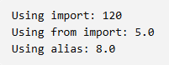
print("Using import:", math.factorial(5)) print("Using from import:", sqrt(25)) print("Using alias:", m.pow(2, 3)) Output:

Conclusion:
Thus, different import mechanisms in Python were demonstrated successfully.

Definition:
Write a program to perform mathematical operations using math module.

Aim/Objective:
- To understand the purpose of the math module.
- To calculate the square root of a number.
- To calculate the factorial of a number.
- To perform power and logarithmic operations.
- To use mathematical constants such as pi.

Source Code:
import math n = 5
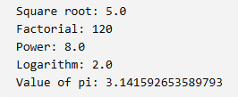
print("Square root:", math.sqrt(25)) print("Factorial:", math.factorial(n)) print("Power:", math.pow(2, 3)) print("Logarithm:", math.log10(100)) print("Value of pi:", math.pi) Output:

Conclusion:
Thus, various mathematical operations were performed successfully using the math module.

Definition:
Write a program to generate random numbers using random module.

Aim/Objective:
- To understand the random module.
- To generate random integers.
- To generate random floating-point numbers.
- To select a random element from a list.
- To shuffle the elements of a list.

Source Code:
import random
print("Random integer:", random.randint(1, 100)) print("Random float:", random.random())
fruits = ["Apple", "Mango", "Banana"] print("Random fruit:", random.choice(fruits)) random.shuffle(fruits)
print("Shuffled list:", fruits)

Output:
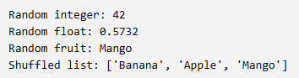

Conclusion:
Thus, random numbers and random selections were generated successfully using the random
module.

Definition:
Write a program to display current date and time using datetime module

Aim/Objective:
- To understand the datetime module.
- To obtain the current date.
- To obtain the current date and time.
- To display date and time in a readable format.
- To extract year, month, and day.

Source Code:
from datetime import date, datetime today = date.today()
now = datetime.now() print("Current date:", today) print("Current date and time:", now) print("Year:", now.year) print("Month:", now.month) print("Day:", now.day)

Output:
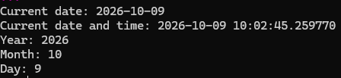

Conclusion:
Thus, the current date and time were displayed successfully using the datetime module.

Definition:

Write a program to perform file and directory operations using os and sys modules.

Aim/Objective:

To perform file and directory operations using the Python os and sys modules.

- To understand the purpose of the os and sys modules.
- To display the current working directory.
- To create a directory.
- To list files and directories.
- To display Python version and command-line arguments.

Source Code:

import os import sys
print("Current directory:", os.getcwd()) if not os.path.exists("MyFolder"):
os.mkdir("MyFolder")

print("Directory created or already exists.") print("Files and folders:", os.listdir(".")) print("Python version:", sys.version) print("Command-line arguments:", sys.argv)

Output:

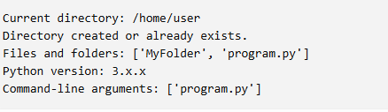

Conclusion:
Thus, file and directory operations were performed successfully using the os and sys
modules.

Practical No. 27

Difinition:
Write a program to copy move and delete files using shutil module.

Aim/Objective:

To copy, move, and delete files using the Python shutil module.

- To understand the purpose of the shutil module.
- To create a file for performing file operations.
- To copy a file to another location.
- To move a file to another directory.
- To delete a file using the appropriate function.

Source Code:
import os import shutil

with open("sample.txt", "w") as f: f.write("Hello Python")

shutil.copy("sample.txt", "copy.txt") print("File copied successfully.")

os.mkdir("MyFolder") shutil.move("copy.txt", "MyFolder/copy.txt") print("File moved successfully.")

os.remove("sample.txt") print("Original file deleted.")

os.remove("MyFolder/copy.txt") os.rmdir("MyFolder")
print("Copied file and folder deleted.")

Output:
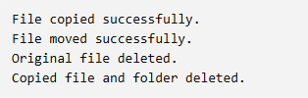

Conclusion:
Thus, files were copied, moved, and deleted successfully using Python file-management functions.

Practical No. 28

Difinition:
Write a program to demonstrate basic regular expression pattern matching.

Aim/Objective:
To demonstrate basic regular expression pattern matching in Python.
- To understand regular expressions.
- To use the re module.
- To identify digits in a string.
- To identify words using patterns.
- To check whether a pattern exists in a string.

Source Code:

import re
text = "My name is Samir and my age is 22." if re.search(r"\d+", text):
print("Number found")

numbers = re.findall(r"\d+", text) print("Numbers:", numbers)

words = re.findall(r"\w+", text) print("Words:", words)

Output:
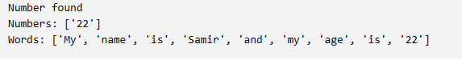

Conclusion:
Thus, basic regular expression patterns were used successfully to identify numbers and words in a string.

Practical No. 29

Difinition:
Write a program to use re module functions such as match search and findall.

Aim/Objective:

To demonstrate the match(), search(), and findall() functions of the Python re
module.

- To understand the re module.
- To use match() to check a pattern at the beginning of a string.
- To use search() to find the first occurrence of a pattern.
- To use findall() to find all occurrences of a pattern.
- To compare the results of these functions.

Source Code:

import re
text = "Python is easy. Python is powerful." m = re.match(r"Python", text)
s = re.search(r"easy", text)
f = re.findall(r"Python", text)

print("Match:", m.group() if m else "Not found") print("Search:", s.group() if s else "Not found") print("Findall:", f)

Output:
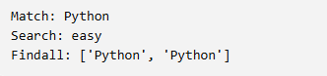

Conclusion:

Thus, the match(), search(), and findall() functions were demonstrated successfully.

Practical No. 30
Definition:
Write a program to extract specific information from a text file using regular expressions.

Aim/Objective:
To extract specific information from a text file using regular expressions in Python.
- To understand text-file handling in Python.
- To read text from a file.
- To use regular expressions to identify email addresses.
- To extract phone numbers from the file.
- To display the extracted information.

Source Code:

First store the details in a re files:

import re

with open("details.txt", "r") as f: text = f.read()

emails = re.findall(
r"[A-Za-z0-9._%+-]+@[A-Za-z0-9.-]+\.[A-Za-z]{2,}",
text
)

phones = re.findall(r"\b\d{10}\b", text)

print("Email addresses:", emails) print("Phone numbers:", phones)

Output:

Email addresses: ['samir@example.com'] Phone numbers: ['9876543210']

Conclusion:

Thus, email addresses and phone numbers were extracted successfully from a text file using regular expressions.

